Determining Switching Technologies

Work with the topology in the following network diagram.
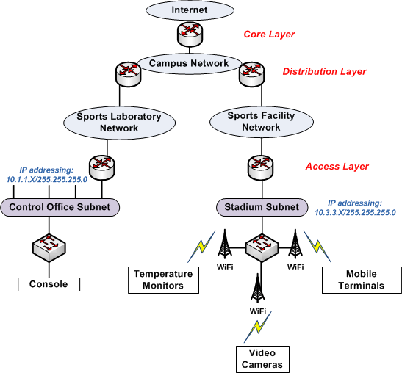
Decide which switching technologies, protocols, and physical media you should use for the following segments of the network:
- The access layer between the Sports Facility Network and the Stadium Subnet
- The Stadium Subnet and all devices connected to it
- The Control Office Subnet and all devices connected to it

In a 2- to 3 pp, indicate and justify your choices for the following items:
- Bandwidth requirements for each wired or wireless segment
- Cable technology
- Wi-Fi technology
- Routers and switches
Be sure to use components currently available on the market today. You may need to search the Internet for vendors.

In addition to your analysis, indicate in your paper where these components should be placed on the diagram.

**Remember to properly cite your sources according to APA guidelines.

